***Assignment –4***

Retrieving Information from Tables.

1. Write a select command that produces the order number, amount, and date for all rows in the Orders table.

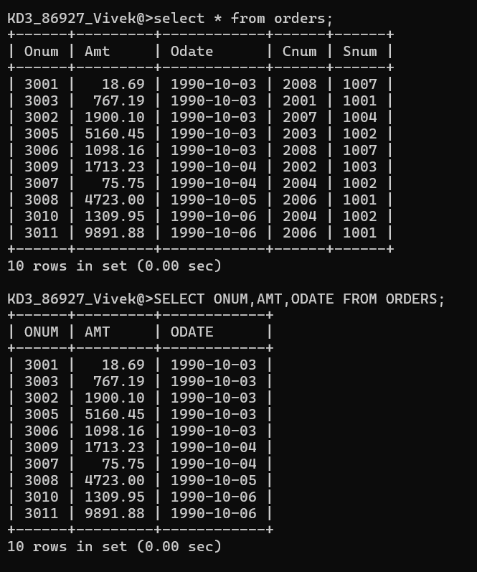

1. Write a query that produces all rows from the Customers table for which the salesperson’s number is 1001.

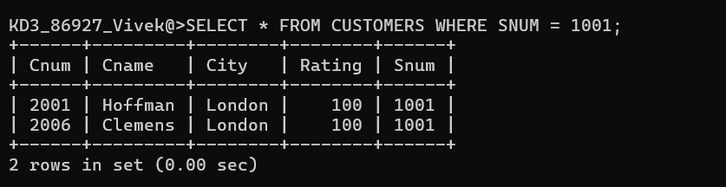

1. Write a query that displays the Salespeople table with the columns in the following order: city, sname, snum, comm.

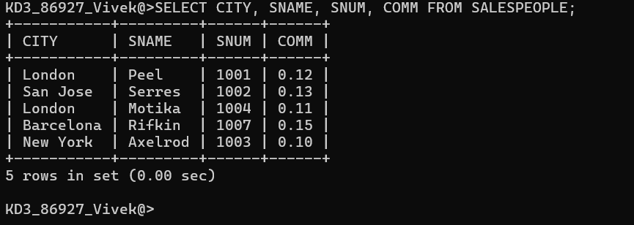

1. Write a select command that produces the rating followed by the name of each customer in San Jose.

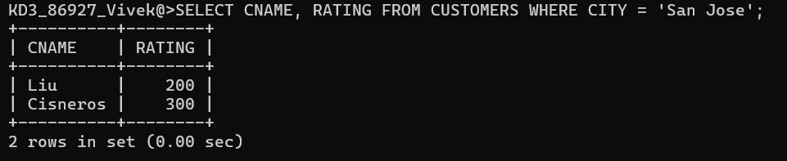

1. Write a query that will produce the snum values of all salespeople (suppress the duplicates) with orders in the Orders table.

